**AIM: Learning basics of Python**

**Program 1:**Write a program to demonstrate the following operators in Python

i-Arithmatic Operator ii- Logical Operator iii- Bitwise Operator

**Solution 1:**

print("\nArithmatic Operators\n")

a=2

b=3

print("a=",a)

print("b=",b)

print('Addition: a+b=',a+b)

print("Subtraction: a-b",a-b)

print("Multiplication: a*b",a*b)

print("Floor Divison: a//b",a//b)

print("Divison: a/b",a/b)

print("Exponent:a**b",a**b)

print("Modulous:a%b",a%b)

print("\nLogical Operators\n")

x = True

y = False

print("x=True")

print("y=False")

print('x and y is',x and y)

print('x or y is',x or y)

print('not x is',not x)

print("\nBitwise Operators\n")

a=2

b=3

print("a=",a)

print("b=",b)

print("AND Operator: a&b= ", a & b)

print("OR Operator:a|b=", a | b)

print("EXCLUSIVE OR Operator:a^b", a ^ b)

print("NOT Operator:~a", ~a)

print("LEFT SHIFT Operator:a<<b=", a << 1)

print("RIGHT SHIFT Operator:a>>b=", b >> 1)

**Output 1:**

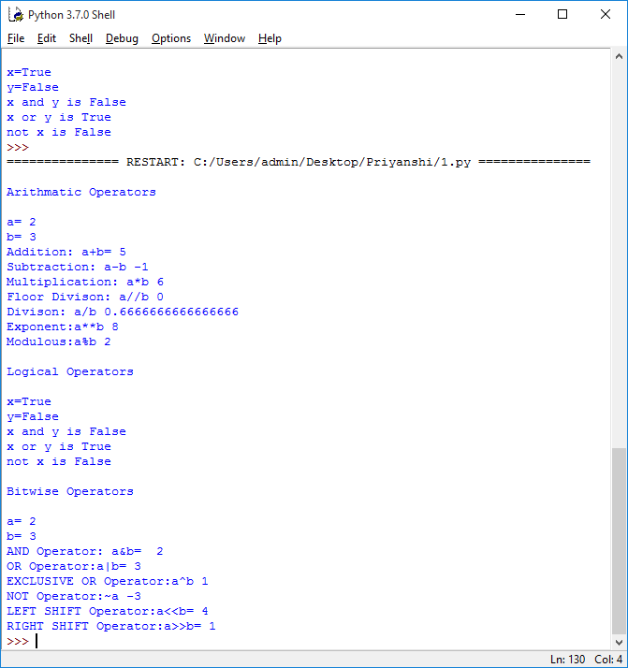

**Program 2:** Write a program to demonstrate the use of membership in Python

**Solution 2:**

list=[1,3,5,7]

a=5

fori in range(0,len(list)*2):

ifi in list:

print(i," in list")

ifi not in list:

print(i," not in list")

if(type(a) is int):

print("a=5,type(a) is int:True")

if(type(a) is not float):

print("a=5,type(a) is not float:True")

**Output 2:**

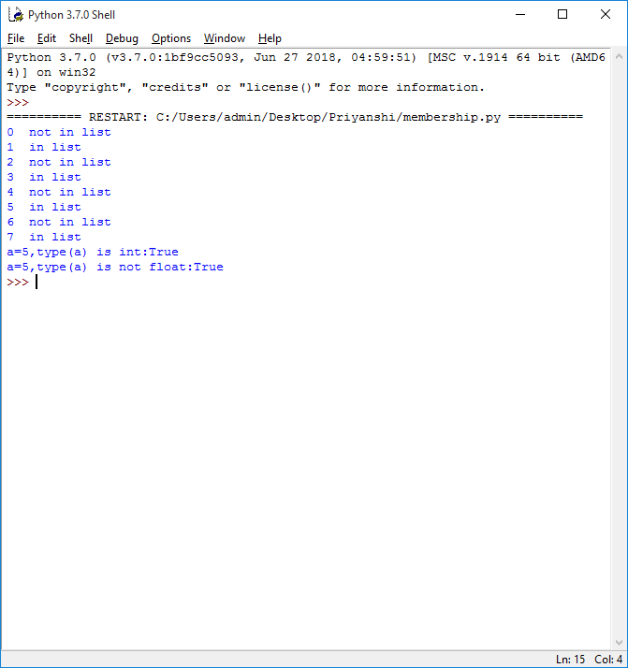

**Program 3:** Write a program to demonstrate various types of Data Structures in Python

**Solution 3:**

print("Data Structure:Array\n")

import array as ar

a=ar.array('i',[1,2,3])

print("Array is:")

fori in range(0,len(a)):

print(a[i],end=" ")

print("\nAppend Function: a.append(10)")

a.append(10)

fori in range(0,len(a)):

print(a[i],end=" ")

print("\nInsert Function: a.insert(2,30))")

a.insert(2,30)

fori in range(0,len(a)):

print(a[i],end=" ")

print("\n\nDataStructure:List\n")

list1= ["Priyanshi","Tanya","Surbhi","Banka","Maitri"]

print("List is:",list1)

print("Accessing a particular item from list as list1[0]:",list1[0])

list1[4] = 160355

print("Changing item value in the list aslist1[4]=160355: ",list1)

print("Length of list is checked as len(list1):",len(list1))

list1.remove(160355)

print("Removing from a list as list1.remove(160355):",list1)

list1.pop()

print("Popping from a list as list1.pop():",list1)

del list1[2]

print("Deleting from a list as del list1[2]:",list1)

print("\nDataStructure:Tuple\n")

l = (1, 2, 3, 4, 5)

print("Tuppleis:",l)

print("Accessing a particular item from tuple as l[0]:",l[0])

print("Negative indexes in tuple as l[-2]:",l[-1])

print("Slicing Operator as l[0:2]",l[0:2])

print("Comparison in tuple when a=(5,6) b=(1,4)")

a=(5,6)

b=(1,4)

if (a>b):

print("a is bigger")

else:

print("b is bigger")

print("\nDataStructure:Dictionary\n")

d = {}

print("Adding key - value pairs to dictionary as d['priya']=160355 d['abc'] = 345 ")

d['priya']=160355

d['abc'] = 345

print("Printing the whole dictionary as d", d)

print("print only the keys as d.keys()",d.keys())

print("Print only values as d.values()",d.values())

print("Check if key exist as 'xyz' in d ",'xyz' in d)

del d['abc']

print("Deleting the key-value pair as del d['abc'] ",d)

print(d)

print("\nDataStructure:Sets\n")

set = set()

print("Adding elements to a set using for loop")

fori in range(1, 6):

set.add(i)

print("Set = ", set)

**Output 3:**

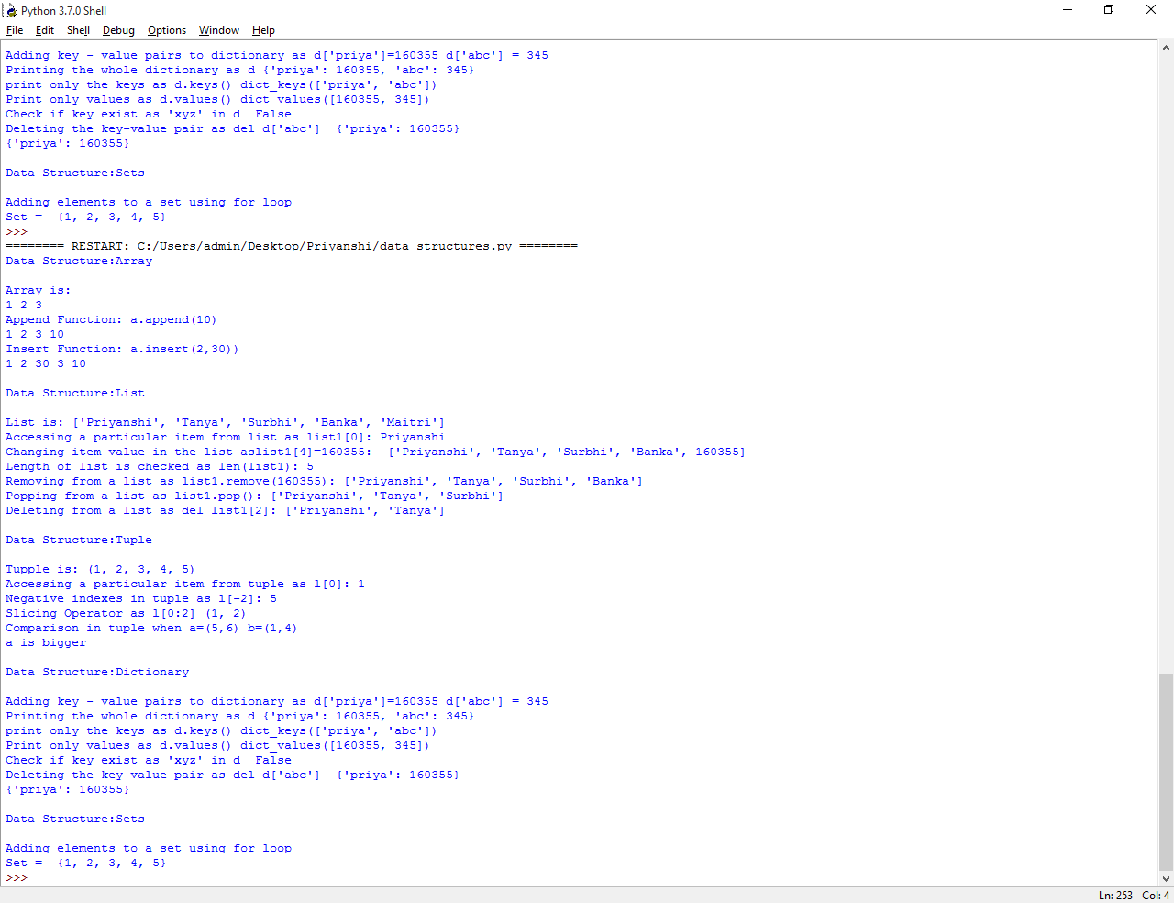

**Program 4:** Write a program to demonstrate the use of user-defined functions in Python

**Solution 4:**

def add(a,b):

returna+b

print(add(5,6))

